
English Language
Intermediate Grade 1st
1st period Exam
……….\20
………………… School

Student's Name : class:

……\ 5 marks
1-Read the following passage and answer the questions below:
Ahmad and his friend Ali love spending time together. On Tuesday, they went to the zoo. On Thursday, they played football in the park. On Saturday, they visited the library and read stories. They had a lot of fun every day they were together.
c- cousins | b- brothers | a- friends | 1- Ahmad and Ali are ……..
c-Wednesday | b-Friday | a- Tuesday | 2- What day did Ahmad and Ali go to the zoo?
c-went shopping | b-played football | a-studied | 3- What did they do on Thursday?
c- library | b-gym | a-restaurant | 4- Where did Ahmad and Ali go on Saturday?
c-Mohammad | b-Ali | a-Sami | 5- Who did Ahmad spend time with?
A.Choose the correct answer.

2-Choose the correct answer.
……\ 5 marks

c-are | b-am | a-is | 1- Omar ………………a student.
c-Why | b-Where | a-What | 2-………day is today?
c-opening | b-opens | a-open | 3- Please …………..your book.
c-am | b-is | a-are | 4- You ………a doctor.
c-Our | b-Her | a-My | 5-…………names are Yahya and Adel.
c-How | b-What | a-When | 6-……………are you?
c-their | b-we | a- she | 7-They are excited about ……graduation day.
c-at | b-on | a-in | 8- The exam is ………..Monday.
c-His | b-My | a-Her | 9- I’m a student. …………..name is Alan.
c- is | b-are | a-am | 10- This is my friend .She ……. a teacher.

3-Do as shown between brackets.
……\ 2 marks
1- This is the teacher. My name is Mr. Ahmed. ………………… ( correct)
2- close the door…………………………………………………………. (write the negative)

……\ 4 marks
4- write the correct word under each picture ( eraser – horse – dolphin - paints )



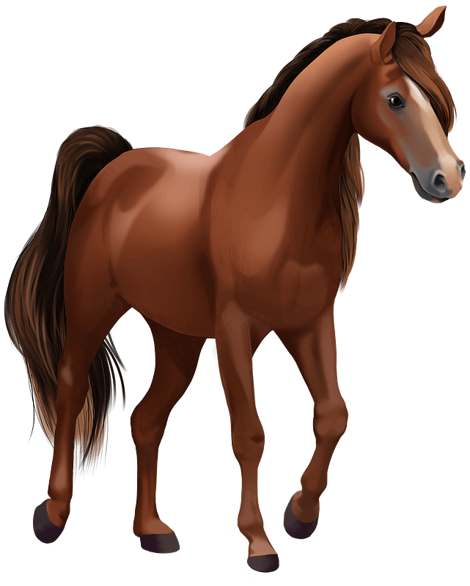
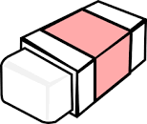

………………………
………………………
………………………
………………………

……\ 2 marks
5- Choose the correct answer.
1- We( cut – color – read ) with scissors.
2-(Life span - Turtle – Baby) is the number of years an animal can live.
.

……\ 2 marks
6.Choose the missing letter.
1- I'm star….ing . I hvaen't eaten anything all day .( v - d - w )
2- My dad has a ….eeting today. ( c – m – g )

7- write the missing letter

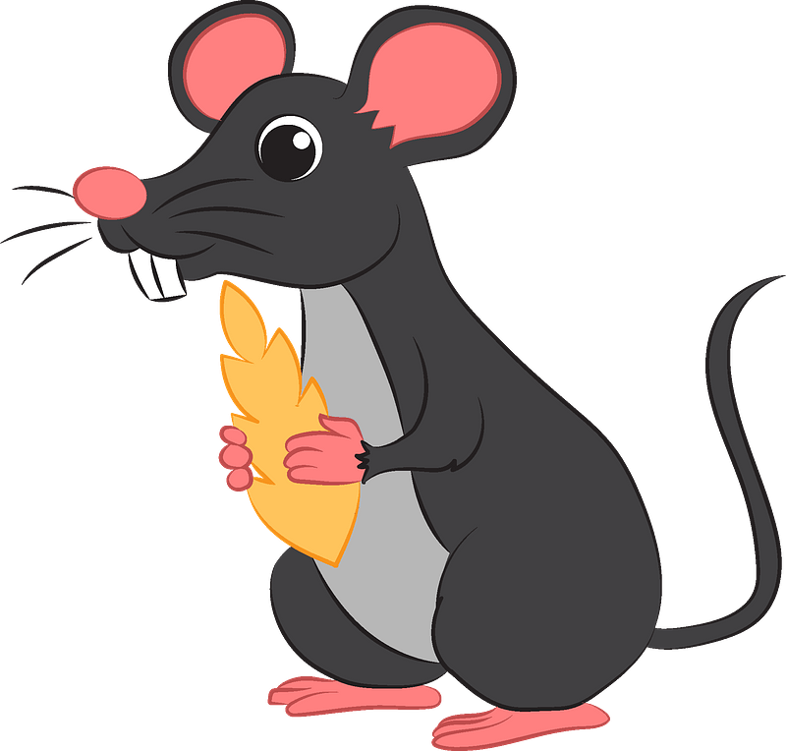
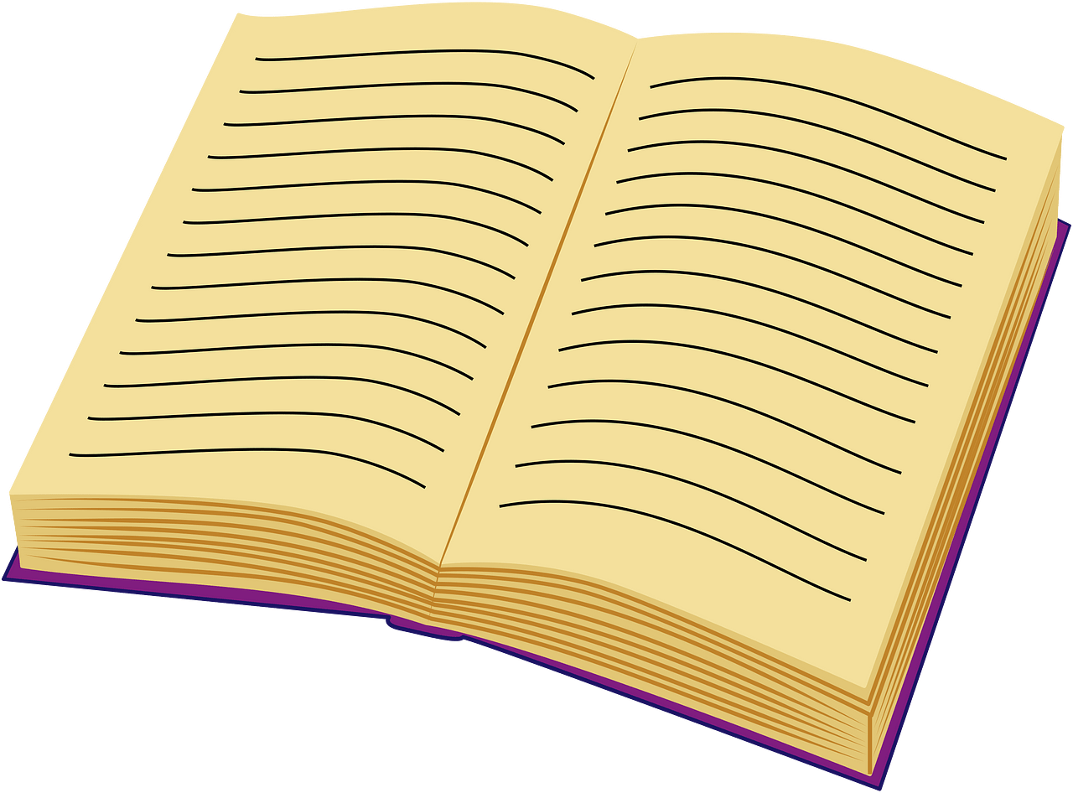

Boo….
….ouse

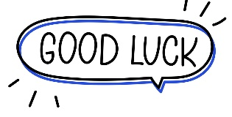

Your teacher:

English Language
Intermediate Grade 1st
period Exam
………………… Intermediate School

Student's Name : class:

Reading comprehension ✦
……\ 5 marks
1-Read the following passage and answer the questions below:
Ali gets up at five o'clock every morning. He performs morning prayer. For breakfast, he likes to eat eggs and bread. He drinks milk. Ali always goes to school by bus. He reaches school at seven o’clock. Later, he has lunch at half past two with her family. In the afternoon, he starts doing his homework at four o’clock. He goes to bed at ten o’clock.

1- Ali gets up at ………… o'clock every morning.
c- ten | b- three | a- five
2- For breakfast, he likes to eat …………. and bread
c- cheese | b- cereal | a- eggs
3- Ali drinks ………………
c- juice | b- milk | a- coffee
4-. Ali always goes to school by ……………..
c-train | b-bus | a-car
5- He goes to bed at ………. o’clock.
c- ten | b- nine | a- one

Grammar ✦
……\ 4 marks
A. Choose the correct answer.
1- You ( is – are – am ) a doctor.
2-(Where – What – Why ) day is today?
3-( What – How – when ) are you?
4- Omar (is – are – am) a student.
5- Please ( open – opening – opens ) your book.
6- I’m a student. (Her – My – His )name is Alan.
7-This is my friend .She (is – are -am) a teacher.
8- The exam is ( in – on – at )Monday.



B. Do as shown between brackets.
1-( Correct)
a-What is you name? ………………
b- Our vacation is on the winter. ………..
2-Write the negative.
a-Close the door…………………………………………………………………………….
3-Write the following dates.
a-2/15 ………………………………………………………………………………………..

……\ 4 marks

✦ Vocabulary
A-choose the correct answer.
1-We( read – cut - swim) books.
2- Open your books. Look at ( page – pencil – read ) twelve.
B- Write the correct word under each picture

……\ 5 marks

cat pencil scissors dolphin

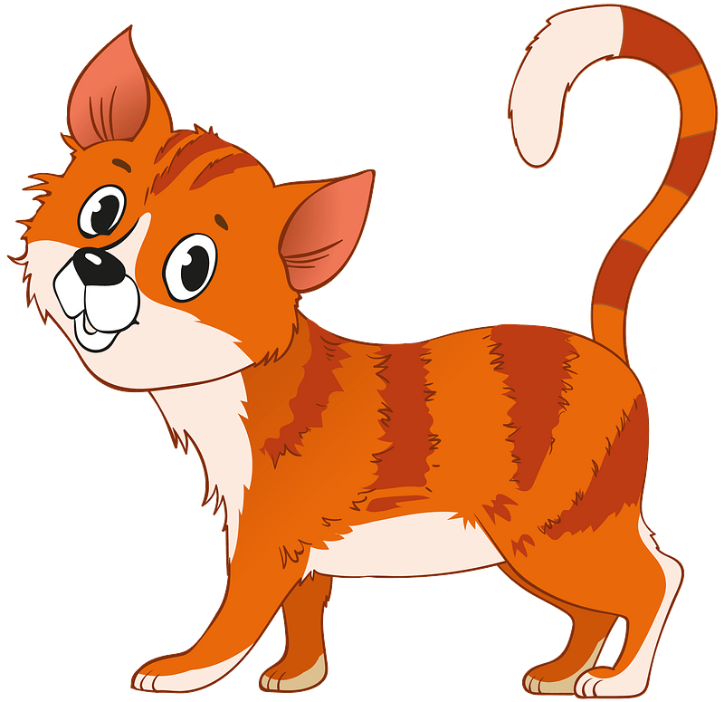
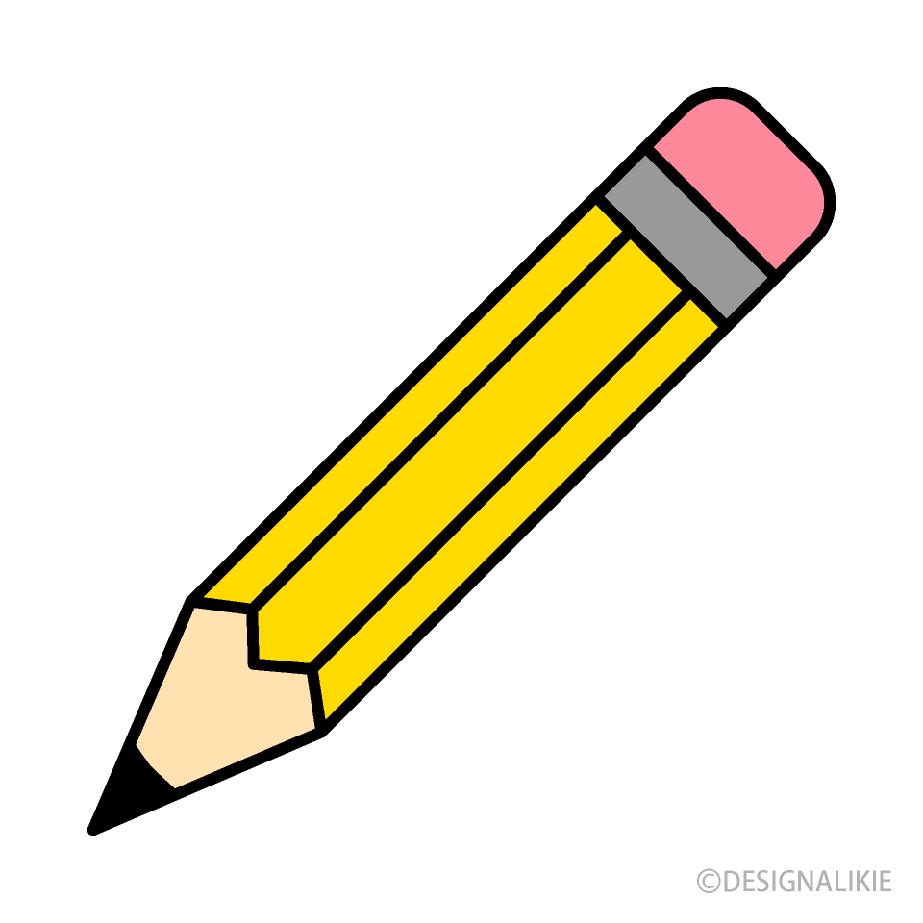
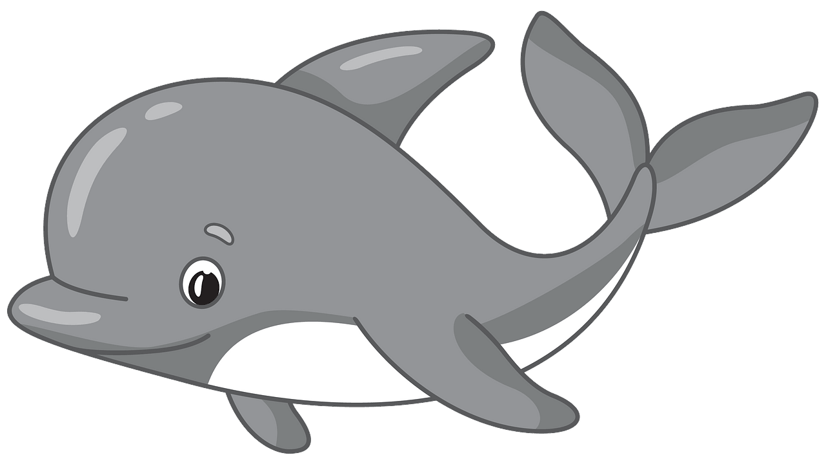


…………………………
…………………………
…………………………
…………………………
✦ Orthography
Choose the corre

……\ 2 marks
A. Choose the missing letter.

1- We’re going sailing on Mo….day. ( n – u – q ).
2- Ni….e to meet you. I'm Fahad. ( p – c – z )

B. Write the missing letter.
Your teacher:

2- ….ouse ( h – m – p )
1-Boo…… ( k – j – a )
The end of the questions
Good luck
Your teacher ………………………
Name:……………………………………………………
Seat: ………………………………………………………

Comprehension
Today, we went on a fun visit to the museum! We saw amazing sculptures and an old poster of a dinosaur. There were also cool fossils and a big skeleton of a human body.
We saw many old things, like toys and old cameras. I found some colorful key chains and tote bags in the gift shop. The guide told us, "Don't touch!" We looked at the old radio, camera, and washing machine. It was a great day of fun!
A/Choose the correct answer:
1. What did they see at the big at the museum?
a) a small toy b) a big skeleton c) a bus
2. What did the guide tell them not to do?
a) run b) play c) touch
3. Where did they see the colorful items?
a) in the sculpture room b) in the gift shop c) home
4. Which animal was on the poster?
a) elephant b) dinosaur c) bird
B/ Fill in the blanks:
5. They saw amazing _________ at the museum. (sculptures/cat/bus)
6. They looked at the old_________. (radio/apple/fish)
7. They went on a fun visit to the _______. (park/zoo/museum)
C/Put (T) for true or ( F )for false:
8. They went on a visit to the zoo. ( )
9. It was a great day. ( )
10. saw many old things.( )

English language
1st grade intermediate
1st term

/20
Mark:

/5

Grammar
A-Choose the correct answer.
- I __ student. (am - are - is)
- She is a teacher, _____ name is Miss Mona. (his - her – they)
- I eat ___ apple. (a - the - an)
- My birthday is ___ January 1st 2013 (in - on - at)
- I play football. ___ Mondays. (at– on – in)
- You _____ my best friend. (are – am – is)
- _____ old, are you? (How – What – When)
- ___________ is your first name? (What- Where – How)
B- correct the errors.
- This is me friend, his name is Ali. _____
- Sara and Mona is teachers. ______
C-Fill in the blanks with the correct preposition (on / in).
- My vacation _______ the summer.
- Our final test is __________ September 21st.

A-Choose the correct answer:
- Hi, how are you? _____ a) I’m ok. b) goodbye c) thanks
- We cut with _______. a) scissors b) pen c) book
- We _____with crayons. a) write b) read c) color
B- Fill in the blanks from the box
- I have a surprise for you,________
- Put your bags _________
- Please sit ________
C/ Write the correct word under the picture

A./ Choose the correct letter to fill in the blank.
- I’m sorr__, Hi Ahmed {y / i / e}
- There are twelve __onths in a year. {n/e/m}

/4

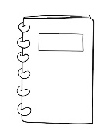
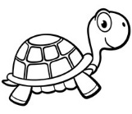
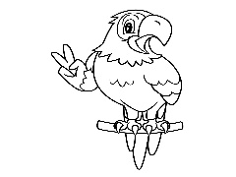

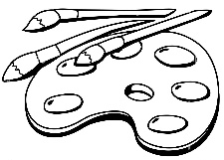
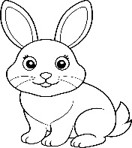
away / guess what! / down
Best wishes
By: Manal Al-Shareef
/2
/5
B/ Write the missing letter

1.Tu__tle (r/l /j) 2. not__book(i/y/e)
Orthography
Parrot / Scissors/Paints/ Rabbit
Vocabulary
/4

