1
1– What is your favorite interest?

I. CHOOSE
A. playing video games. B. Yes, I like it .
2– Who designs houses?

A. A pilot. B. An architect.
المملكة العربية السعودية |  |  | اسم الطالب/ ......................................
وزارة التعليم
إدارة التعليم بمنطقة |  |  | المادة : انجليزي
مدرسة : |  |  | الزمن :
 |  |  | الصف : الخامس فصل ( )
شفهي | تحريري |  |  | المجموع
10 / | 10 / |  |  | 20 /
Top goal2 اختبار الفترة الأولى الفصل الأول - للعام الدراسي 1448– لغة انجليزية –– للصف
اسم الطالب / هـ الفصل /

2. CHOOSE OR
1.5

On hundred twenty two.
I do exercise .
I’ll dance down here!






3. DO AS SHOWN BETWEEN BRACKETS
1.5

1. April – march – February – January (Rearrange) …………………………………………………….
2- (Rewrite the words using un) lucky - clean ………..…..…….. …………..………
4. CHOOSE
1

How many | How long | 1- _________ students are in your class ?
painted | paints | 2- She _______ an amazing landscape yesterday.

3
4. CHOOSE

 |  |  |  |  |   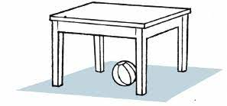
Lion | Rainbow | horrible | reporter | entrance | Gate
Horse | Snow | tidy | doctor | screen | Date

5. CHOOSE
2

Choose the correct letter: ( k - r - g - d ) )

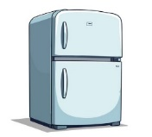 | 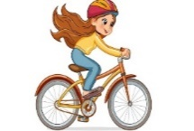 |  | 
F_idge | ri_e a bike | ori_ami | Wa_e up

___________________________________________________________________________________________________________________________________________________________________________________________________________________________________
Controlled writing

4

Good luck T.



………………… School
English Language
elementary Grade …..
period Exam
…………….\20
الاسم: الصف:

……\ 4 marks

General questions

A.Answer the questions
She's a writer. |  | What special interest do you have? | 1
an architect |  | What does she do? | 2
My special interest is origami. |  | What are you going to do after school? | 3
I am going to play tennis |  | Who designs houses? | 4

Controlled Writing
……\ 1 marks
A-reorder.
1- horrible \ The \ is \ monster
a-The monster is horrible. b-horrible is the monster.

……\ 4 marks

Reading short sentence
 | 1- They look angry at the fair.( )
 | 2- The key is under the mat ( )
A-Put ( ✔ ) or ( X )
B. Choose the correct answer
c-friendly | b-unkind | a-messy | 1- My hair is………… . I need to brush it.
c-Wi-Fi | b-mat | a-else | 2- The………… password is AB@1234

……\ 4 marks

Grammar
A-Choose the correct answer.
c- writing | b- writes | a- write | 1- He is ……..in his notebook.
c-eat | b-ate | a-eats | 2- You didn’t …….pizza for lunch.
c-going | b-goes | a-go | 3- I won’t ………. to the park.
c-reading | b-reads | a-read | 4- Khalid is going to……book this evening.

Vocabulary
A.Choose the correct word under each picture
……\ 5 marks

 |  | 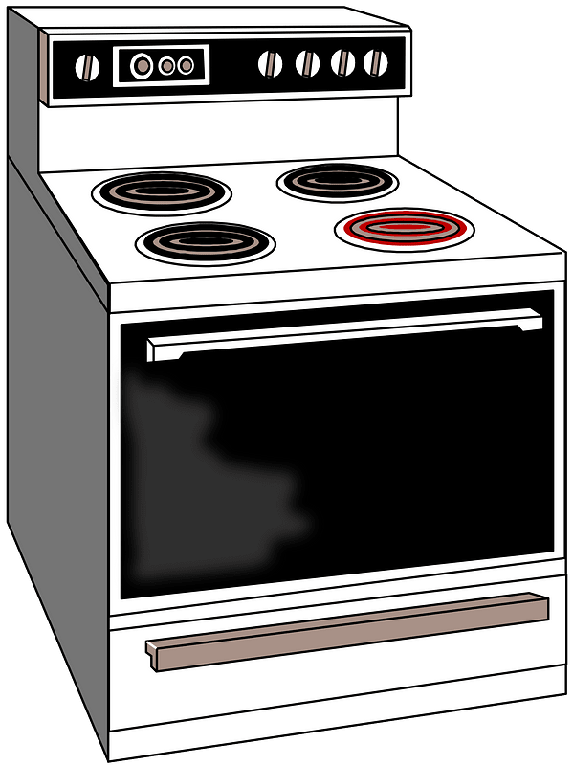  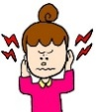 |  | 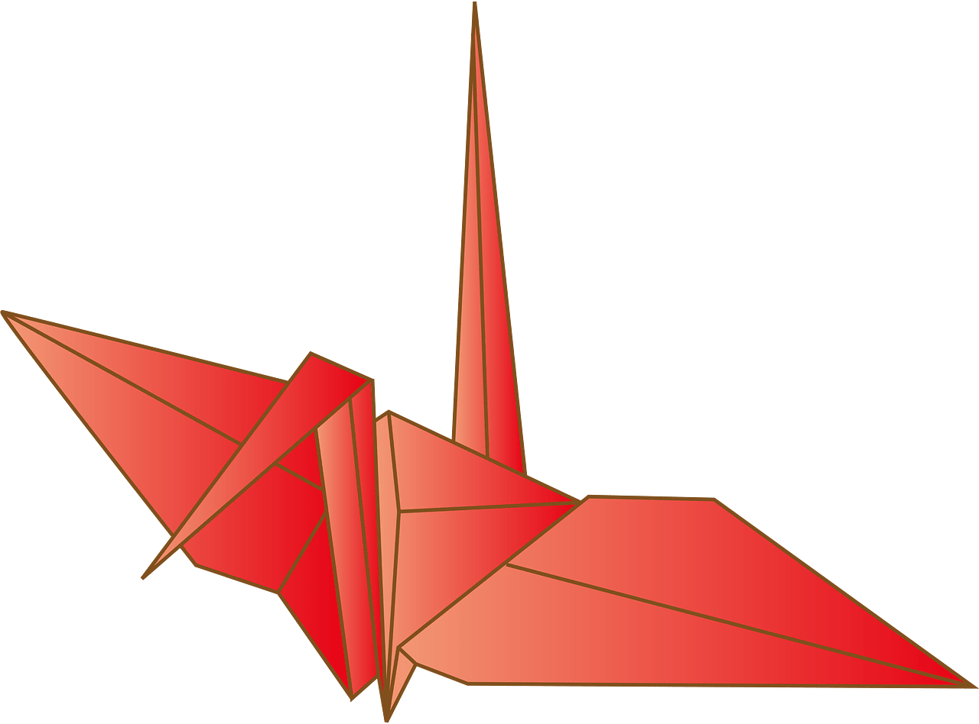
slide | corner | noisy | fridge | television
house | Shelf | unlucky | oven | origami
……\ 2 marks

Orthography
A. Fill in the missing letters
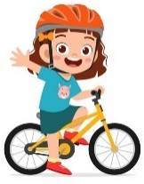



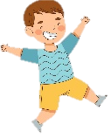
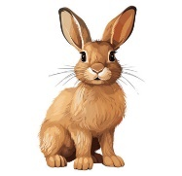

4- cus….ion
( i - v - h)
3- ama…..ing
( z – r – l )

( s – t - o)
2-……ate
( u – g - p )
1- ex…..ited
( c – r - y )


Your teacher:

Your teacher …..:…………………………….

5th &6th Elementary Grade
First Term

10
. . First Exam - 1447 AH
Name: ………………………………………………………….………………. Class : …………..
- General Questions:
- Choose the correct answer:
1- In which month is the Saudi National Day holiday?
a- My birthday is in October. |  |  |  |  | b- It is in September.
2- What is your favorite interest?
a- My favorite interest is playing the guitar. |  |  |  |  | b- I like it because it is fun.
- Controlled Writing:
- Fill in the blank with the word that has the same meaning:
tidy – special – noisy

1- ………………….. : something unique.
2- ………………….. : clean and organized.
- Reading short sentence:
- Read the sentences then match them with the correct pictures:
 |  | 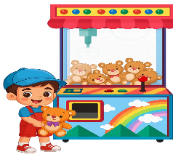 | 
a-_They go to food festival.  b-_They go to school. | a-_It is a rainbow.  b-_It is a mountain. | a-_He is lucky.  b-_He is popular. | a-_It is frightening.  b-_It is amazing.

IV . Grammar:
- Choose the correct answer:
- ……….…… students are in your class?
- How much |  |  | - How many |  |  |  |  | - How long
- I ………….. fruit with yogurt yesterday.
- eat |  |  | - eating |  |  |  |  | - ate
- He doesn’t ……………… horror movie.
- watch |  |  | - watches |  |  |  |  | - watched
- We …………… to have a picnic.
a- wanting |  |  | b- are wanting |  |  |  |  | c- want
V. Vocabulary:
- Choose the correct answer:
 |  |  |  |  |  | 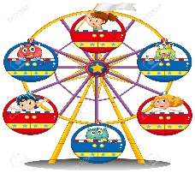 |  |  | 
- date  - year |  | - early  - late |  |  |  | - ride  - origami |  |  | - nervous  - excited
VI. Orthography:
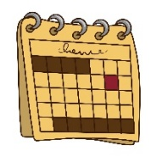
- Choose the correct missing letters:
  im__ortant |  | __alandar |  |  |  |   ex__ellent |  |  |   rain__ow
b | p | c |  | k |  | c | s |  | d | b

BEST OF LUCK
Ms. Tahani Al-Ghamdi

1
1– What is your favorite interest?

I. CHOOSE
A. playing video games. B. Yes, I like it .
2– Who designs houses?

A. A pilot. B. An architect.
 |  |  | اسم الطالب/ ......................................
 |  |  | المادة : انجليزي
مدرسة : |  |  | الزمن :
 |  |  | الصف : فصل ( )
شفهي | تحريري |  |  | المجموع
10 / | 10 / |  |  | 20 /
Top goal2 اختبار الفترة الأولى الفصل الأول - للعام الدراسي 1448– لغة انجليزية –– للصف
نموذج اجابة

2. CHOOSE OR
1.5

On hundred twenty two.
I do exercise .
I’ll dance down here!



3. DO AS SHOWN BETWEEN BRACKETS
1.5

1. April – march – February – January (Rearrange) January – february – march – April
1- (Rewrite the words using un) lucky - clean - happy unlucky unclean unhappy
4. CHOOSE
1

How many | How long | 1- _________ students are in your class ?
painted | paints | 2- She _______ an amazing landscap yesterday.

3
4. CHOOSE
lion - screen - reporter

 |  | 
lion | reporter | screen


2

Choose the correct letter: ( k - r - g - d ) )

Fridge | ride a bike | origami | Wake up

___________________________________________________________________________________________________________________________________________________________________________________________________________________________________
Controlled writing

4

Good luck T.

