
English Language
Intermediate Grade 2nd
period Exam
………\20

Kingdom of Saudi Arabia
Ministry of Education
………..Education Directorate
………………… Intermediate School

Student's Name : class:
Reading comprehension ✦

……\ 5 marks
1-Read the following passage and answer the questions below:
Sara went on a safari in Africa. She saw lions, elephants, and giraffes. The animals were big and beautiful. She took many pictures with her camera. Sara rode in a jeep with a guide. The guide told her facts about the animals. She also saw zebras running in the grass. The weather was hot and sunny. Sara wore a hat and drank lots of water. She had a great time on the safari and wants to go again.

1-Where did Sara go on a safari?
c- Australia | b- Asia | a- Africa
2- She saw ……….., elephants, and giraffes.
c- lions | b-tigers | a- gorillas
3- What did she use to take pictures?
c- camera | b- phone | a- computer
4- What was the weather like?
c- windy | b- sunny | a- rainy
5- What did Sara wear?
c- a skirt | b- a dress | a- a hat

……\ 4 marks
Grammar ✦
A. Choose the correct answer.

c- playing | b- played | a- play | 1- They are going to ……bowling.
c- travelling | b- travels | a- travel | 2- I will …………… to Jeddah.
c- slows | b- slowly | a- slow | 3- Omar drives………………
c- boiling | b- boils | a- boil | 4- If you heat the water to 100ْC , it…….
c-going | b- go | a-went | 5- Imad is ……….. to climb a mountain.
c- Where | b- Who | a- What | 6-………… are they going to write to ?
c- feel | felt b- | a- feels | 7- If it’s hot and humid, I don’t ………. very active.
c- goes | b- going | a-go | 8- Will they ……………… to the park ?

……\ 2 marks
B. Do as shown between brackets.
1-Correct
a- if I am sick , I may stayed at home. …………………….
b- Amal is going to cooked the dinner.. …………………… ……………………….

Turn the page
2- ( Give the negative ).
……\ 2 marks
a- Nora will eat fast food.
………………………………………………………………..…………….…
3- ( use adverb of manner)
a- Asma is a good writer
………………………………………………………………………………..…
.
✦ Vocabulary
……\ 5 marks
A.Match the correct word for each picture.
thunderstorm coral reefs relaxing rainy

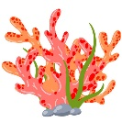

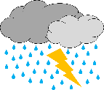
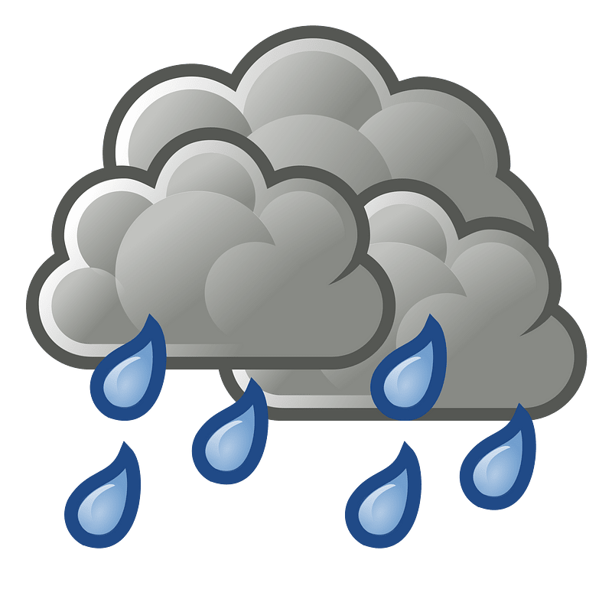

………………..
………………..
………………..
………………..

B-choose the correct answer.
1- It will be 40 degrees Celsius today. That’s ( hot – cold - storm ).
2- Jazan, in southwestern Saudi Arabia, is a (coastal - exciting -ancient ) city on the Red Sea.
3- Where are my sunglasses? It’s really(snowy – rainy - sunny) today.

✦ Orthography
Choose the corre

……\ 2 marks

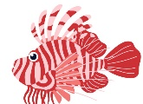
A-Write the missing letters.
2-Win…….y
1-lion….…ish

B.Choose the missing letters.
1- What’s your favorite seaso… of the year? ( b – v – n )
2- I’m aller….ic to shrimp. ( g – u – f )
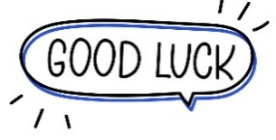

Your teacher …..:…………………………….


Kingdom of Saudi Arabi Name: ……………………………
Ministry of education Class: 2nd Intermediate Grade
20 /
Hefar Intermediate School Mid-Term Exam Third Term
- Comprehension:
Read the passage to answer the questions below:
Jim and his brother, Ted love the snow. When it snows, they go outside and play. Jim and Ted like to build a snowman. They put a hat and scarf on their snowman. They also use a carrot for the nose. Then, they go home, and their mom gives them hot cocoa.
- Choose the correct answer:
- This text takes place in the ……………… season.
- summer b- winter c- spring
- The boys use the ………………. for the nose.
- apple b- cucumber c- carrot

- Check ( T ) or ( F ) :
- Jim and Ted are friends. ( )
- The mother prepares coffee for kids. ( )

- Grammar:
- Choose:
- (How – Who – When) is your best friend?
- Mona is a good cook. She cooks (good – goodly – well).
- I will (meet – meets – meeting) you at seven.
- If it (rain – rains – will rain), they won’t play tennis.

- Do as shown between brackets:
- (Rewrite the sentence using adverbs of manner)
- Omar is a careful driver.
…………………………………………………..
- Sara will stay home on Saturday. (Make a Yes/No question)
…………………………………………………..
- Vocabulary:
- Write the words under the pictures:
oasis – gulf – mosquito – cloudy – hurricane
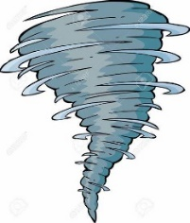
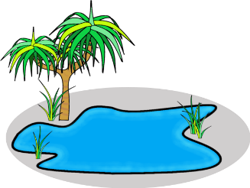

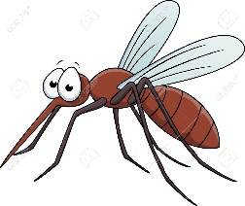

_____________ _______________ ________________ ______________

- Classify the words:
spring – dry – fall – windy

Seasons | Weather words

- Orthography:
- Choose the correct missing letters:
- I am alle__gic to dairy products.
- k | - l | - r
- Jeddah is a coast__l city.
- a | - e | - i
- It’s going to rai__ today. You need your umbrella.
- m | - u | - n
- The color of lea__es is green in summer.
- f | - v | - b

Good Luck
Ms. Tahani Al-Ghamdi



Kingdom of Saudi Arabia
Ministry of Education
………… Education Directorate............
…………..……………….. Intermediate School

20
Total

Midterm Test units 12 & 13
Second Intermediate Grade

Name ………………………………… Class ………………………………
__________________________________________________________________________________________
/ 4
Comprehension

Read the following then answer the questions:

The winter months are December, January and, February. It's cold and rains in winter. We wear
heavy clothes in winter. The summer months are June, July and August. It's hot in summer. People wear light clothes. They go to the to the park or to the sea, some children like to play football and fly their kites.

A- Put (√ ) for true or ( ᵡ ) for false :

( ) | 1. The winter months are June , July and August .
( ) | 2. They go to the to the park or to the sea in summer.

B- Choose the right answer:

spring | autumn | winter | summer | 1- It is hot in _______.
jacket | clothes | glasses | shoes | 2- We wear light ____in summer.
_________________________________________________________________
/ 5
Grammar

Choose the right answer:

1- _____ old is Ali ?
D. Where | C. How | B. Who | A. When
2 - I am _________ travel to Jeddah next month .
D. going | C. going to | B. will | A. go
3 - Riyadh is _____ _____.
D. beautiful a city | C. a beautiful | B. a city beautiful | A. a beautiful city
4 - Maybe I_________ drive.
D. am going to | C. go | B. will | A. am going
5 . Jane: Will it be sunny tomorrow? Amira: No, ___ ____ .
D. it will | C. won't it | B. will it | A. it won't.

Vocabulary
/ 4

A- Choose the best answer to fill in the blank:
1. This place is ____. You can learn about traditions from around the world here.
D. unique | C. peaceful | B. exotic | A. cultural
2. This place is ____. It was built thousands of years ago .
D. modern | C. historical | B. adventurous | A. noisy
3- It’s __________ today. Hold on to your hat!
D. hot | C. cold | B. windy | A. funny
4- ______ is usually sunny, really hot, and very dry
D. cloud | C. summer | B. rain | A. winter
B- Put the right word under its picture:
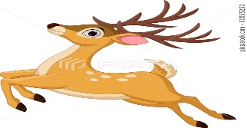 | 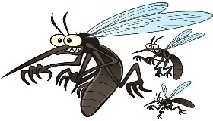 | 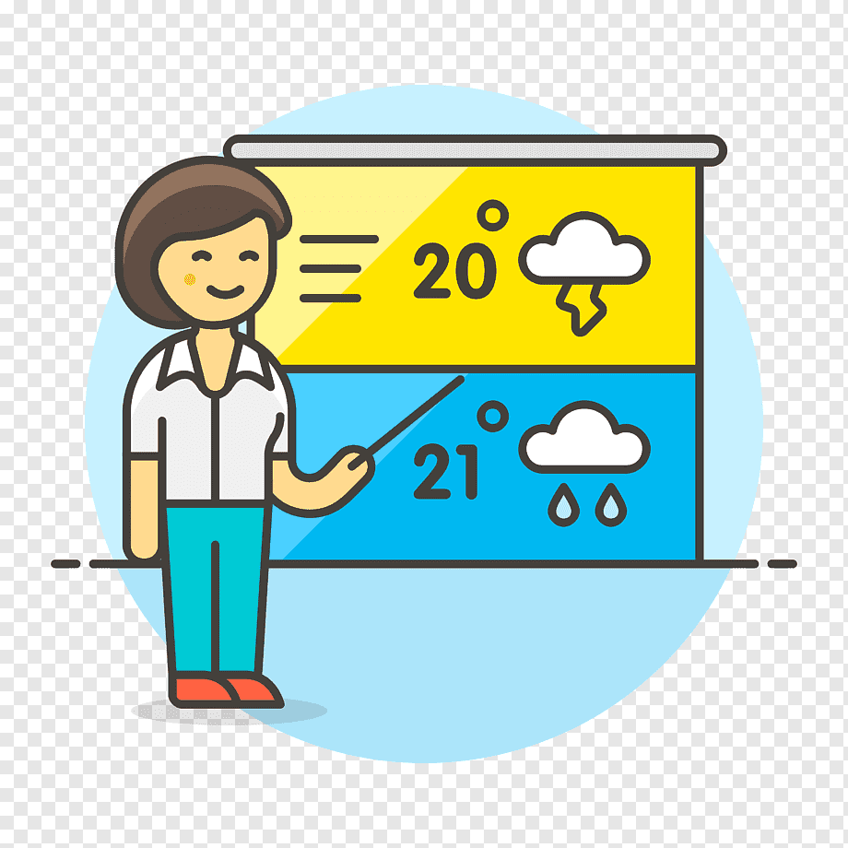 | 
sunny , forecast , buck , mosquitoes
/ 4

_______________________________________________________________________________
/ 3
Orthography

Choose the correct letter:
g | s | v | 1. I live on an i__land .
r | t | d | 2. We’re staying in a comfortable ho__el .
n | h | m | 3. The cli__ate in the city of Jazan is very hot .

Good luck T.

English Language
Intermediate Grade 2nd
period Exam
Kingdom of Saudi Arabia
Ministry of Education
………..Education Directorate
………………… Intermediate School

Student's Name : class:

Reading comprehension ✦
……\ 5 marks
1-Read the following passage and answer the questions below:
Autumn is our favorite season. We enjoy the color of the leaves. It ranges from yellow to dark brown. The grey sky makes it all look like a beautiful painting. Today is Wednesday .It is hot and sunny in Saudi Arabia in June .I am sitting in the garden .My mother is in the kitchen .My brother is in the living –room .He is reading a book.

1-Autumn is a …………………………..
c- month | b- year | a- season
2-The leaves range from yellow to dark ……………
c- brown | b- blue | a- pink
3-Today is …………..
c- Wednesday | b-Sunday | a-Monday
4- It is hot and ………….. in Saudi Arabia
c-snowy | b- sunny | a- rainy
5- Mother is in the ……………………….
c- living room | b- park | a- kitchen
Grammar ✦
……\ 4 marks
A-Choose the correct answer:
1- They are going to ( play – played – plays ) bowling.
2- If it’s hot and humid, I don’t ( feel – feels – felt ) very active.
3-I will ( travel – traveling _ travels ) to Jeddah.
4- Imad is ( go – goes – going ) to climb a mountain.
5-If you heat the water to 100ْC , it( boil – boils – boiling ).
6- Omar drives ( slow – slows – slowly ).
7- How will he ( gets – getting -get) to work?
8- (what – where – who ) are they going to write to ?

B-Do as shown between brackets.
1-(correct)
a- Ali is goes to hang out with his friend. …………
b-if I am sick , I may stayed at home. …………….

2-(Give the negative)
a- It’ll be cold and snowy.
……………………………………………………………………………….

3-( use adverb of manner)
a- Asma is a good writer
…………………………………………………………………………………
4- (answer)
a-is he going to play tennis?
Yes,……..…………………………………………………………………….

……\ 4 marks

✦ Vocabulary
……\ 5 marks
A-Choose the correct answer.
1- Where are my sunglasses? It’s really(cloudy -snowy-sunny) today.
2-Jazan, in southwestern Saudi Arabia, is a (coastal - exciting -ancient ) city on the Red Sea.

B- Choose the correct word for each picture

oasis - cloudy - thunderstorm - noisy



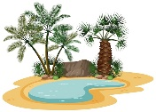

……………………
……………………
……………………
……………………
✦ Orthography
Choose the corre

……\ 2 marks
A-Choose the missing letter.
1- I’m aller….ic to shrimp. ( g – u – f )
2-It's ten degrees belo…. zero (-10). ( d – w – p )
3- What’s your favorite seaso… of the year? ( b – v – n )
4- The gui..e is going to show us around the site.( d -j – s)

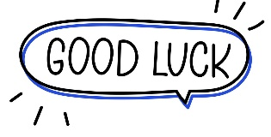
The end of the questions
Good luck
Your teacher ………………………
Your teacher:

