|  |  |  |  |
| --- | --- | --- | --- |
| **المملكة العربية السعودية** |  | **المادة:** | **اللغة الانجليزية (استماع)** |
| **وزارة التعليم** | **الصف** | **الرابع** |
| **الادارة العامة للتعليم بـــ** | **التاريخ:** | **/ /1446 هـــ** |
| **مدرسة الابتدائية** | **الزمن:** | **نصـف ساعة** |
| **اختبار نهاية الفصل الدراسي الاول – الدور الأول للعام الدراسي 1446 هـ**  5  **اسم الطالب ___________________________________ الصف_______ رقم الجلوس_________** | | | |

**Listen and circle the correct answer:**

|  |  |  |
| --- | --- | --- |
| 1. **What does the girl do after school?** | |  |
|  | She reads a book . |
|  | She plays with her brother. |
|  | She goes to the park with her sister. |

|  |  |  |
| --- | --- | --- |
| 1. **Norma loves to go to the beach with her_____** | |  |
|  | granddaughter and grandsons |
|  | aunt and uncle |
|  | dad and mom |

|  |  |  |
| --- | --- | --- |
| 1. **Her brother is kind and ______** | |  |
|  | helpful |
|  | busy |
|  | naughty |

|  |  |  |
| --- | --- | --- |
| 1. **The man has big arms. He's _____** | |  |
|  | lazy |
|  | weak |
|  | strong |

|  |  |  |
| --- | --- | --- |
| 1. **The boy gets up every morning at :** | |  |
|  | 6:30 |
|  | 6:45 |
|  | 6:00 |

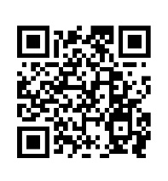

[**رابط الاستماع**](https://www.youtube.com/watch?v=z7KrggCQhcc&t=6s)

**Audio Script:**

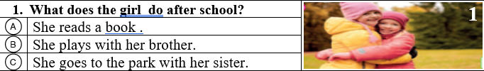

1



**Boy:** What do you do when you finish it?

**Girl :** It depends. I often play computer games or ***go to the park with my sister***.

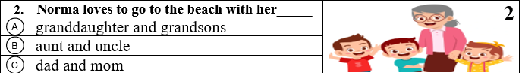



2

**Interviewer:** What about you, Norma? What do you like to do with your family?

**Norma:** I love to go to the beach with my ***granddaughter and grandsons***

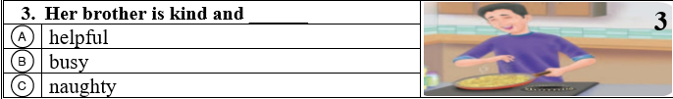

3

**Boy:** Do you have any brothers or sisters?

**Girl :** Yes, just one brother. He’s nice because he’s kind and ***helpful***.

**Boy :** That’s nice**!**

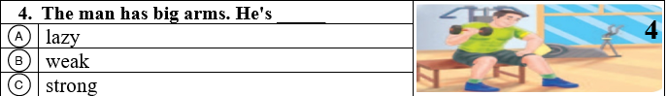

**Boy:** That man in the gym has big arms. He’s ***strong***

4



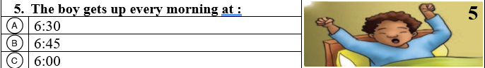

5



**Boy1:** Do you have a morning routine on school days?

**Boy 2 :** Yes, I do. I get up every morning at ***six o’clock***