

**Kingdom of Saudi Arabia**

**Ministry of education**

**…….. Primary school**

**Sixth primary school**

**1.30 hours**

**30**

**الاختبار النهائي للصف السادس الفصل الدراسي الأول.**

أسم الطالب: الفصل: الدرجة:

رقم الجلوس:

**Reading Comprehension** ✔

My dad is a doctor . He works in a clinic . My mom is a teacher . They usually come home late and tired , so me and my sister often help with the house chores . My sister always cooks lunch and I help her . I sets the table and wash the dishes . at night we usually order food from different restaurants .

/ 60001122222222222222222222222222222222222222222222222222222222222222222222222222222222222222222222222222222222222222222222222222222222222222222222222222222222220005

pppppppppp12222222222222222255555555

**Mark ✔ for true ✖ for false**

/ 6

1- The father is a doctor ( )

2- The mother is a nurse ( )

3- The sister always cooks lunch ( )

4- The brother always cooks dinner ( )

**CHOOSE**

My dad is a ( **Doctor , Teacher , *Chef ).***

My sister always cook a ( **lunch , dinner , *breackfast ).***

***_____________________________________________________________________***

/ 6

**Vocabulary**

|  |  |  |  |  |  |
| --- | --- | --- | --- | --- | --- |
| **CHOOSE the correct answer:** | | | | | |
| Free Simple Vector Chicken (White ... | Pizza Clipart Graphic by Illustrately · Creative Fabrica | Free Bus Vector Art - Download 250+ Bus ... | Contest - Picture This Clothing | Bucket | Illustrations, Art, Spring | 77,359 Friends Clipart Images, Stock Photos & Vectors | Shutterstock ... |
| Chicken  lion | Pizza  fish | ***bus***  rabbit | Car  comic book | Broom  bucket | Exciting  Helpful |

**_________________________________________________________________**

/ 5

**CHOOSE the correct answer :**

|  |  |  |
| --- | --- | --- |
| 1- How often …………………… you see your cousins? | ***A- do*** | ***B- have*** |
| 2- How often …………………… he take the bus ? | ***A- has*** | ***B- does*** |
| 3- Whose dress is that ? It is …………………………… | ***A- mine*** | ***B- I*** |
| 4- Whose bike was it? It was ……………………………… | ***A- his*** | ***B- he*** |
| 5- Whose teddy bear was it? It was ………………. | ***A- yours*** | ***b- you*** |

/ 4

|  |
| --- |
| **Read the sentences then match them with the correct pictures:** |
| |  |  |  |  | | --- | --- | --- | --- | | Download Transportation / Transportation Home Png Free - Get On The Bus ... |  |  | Brecksville Kids Dentistry | Pediatric Dentist | Brecksville, OH | | a-_I get on the bus.  b-_I get off the bus. | a-She is washing the dishes.  b-_She is lazy. | a-_he is playing.  b-he is feeding animal. | a-_I often go cycling  b-_I often go fishing |   **________________________________________________________________** |

**Orthography✔**

/ 4

|  |  |  |  |  |  |  |  |
| --- | --- | --- | --- | --- | --- | --- | --- |
| **CHOOSE the correct missing letters:** | | | | | | | |
| Strong man on fire screaming cartoon. Vector clip art illustration ...  **st__ong** | | Camera Illustration Images | Free Vectors, Stock Photos & PSD  **ca__era** | | Premium Vector | 15397  **parr__t** | | **g__itar** | |
| **r** | **c** | **m** | **n** | **a** | **o** | **e** | **U** |

**_________________________________________________________________**

/ 5

**General Questions**

|  |
| --- |
| **CHOOSE the correct answer:** |
| **1- Can I help you with your homework?**  a- Yes, please b- I think fish |
| **2- What are you doing now?**  a- I am watching TV b- I have 3 brothers |
| **3- Who is chatty in your family?**  a- My sister likes to talk a lot b- My brother doesn’t talk a lot |
| **4- How often do you see your cousins?**    a- It is mine b- I always see them |
| **5-** Whose pen was it**?**  a- Yes, Please b- It was his |

|  |  |  |  |  |  |  |  |
| --- | --- | --- | --- | --- | --- | --- | --- |
|  |  | | | | | **الــم ـملكة الـعربية السـعوديـة بسم الله الرحمن الرحيم وزارة التعليم الإدارة العامة للتعليم بمنطقة مكتب مدرسة** | |
|  | **التوقيع** | **المصحح** | **كتابةً** | **الدرجة** | **السؤال** |
|  |  |  |  |  | **س1** |
|  |  |  |  |  | **س2** |
|  |  |  |  |  | **س3** |
|  |  |  |  |  | **س4** |
|  |  |  |  |  | **س5** |
|  |  |  |  |  | **س6** | أسئلة اختبار نهاية الفصل الدراسي الاول للعام الدراسي 1446هـ    ) الدور الأول ( | |
|  | المجموع : | | | | |
|  | المراجع : التوقيع : | | | | |
|  | |
| **1**   1. First 2. The 3. Your 4. 5-   6-    **2**  1.  2.  3. M  4.  **3**  **صفحة 1** | **المادة: اللغة الإنجليزية الصف: الخامس الابتدائي الزمن: ساعة ونصف ) الفصل : 5 / (** | | | | |  |
| **اسم الطالب /** ................................................................. **رقم الجلوس )** .........................(   |  | | --- | |  | | 6 |   **.General Questions: A. Match "A" with "B":**  **)**    🗴    **(**    **r**  **o**    **)**    🗸    **(**    **Choose**    **:**  **.Reading Short Sentence**  B    A    (        )      parents    .    (      )        daddy  .      .    st  1    )        (    (        )  I    sometimes sweep the floor  .    (      )  I  t was brilliant    .    (      )    I am reading a comic book  .    informal form of "dad" is ……….    mom and dad are your    …………  What are you doing?  How was your first vacation abroad  ?  How often do you sweep the floor  ?    4     |  |  |  |  |  |  | | --- | --- | --- | --- | --- | --- | | She is tired. 383,634 Afraid Images, Stock Photos, 3D objects, & Vectors | Shutterstock | | | | 🗸 | 🗴 | | He is fishing in a boat. Boat Cartoon Fishing Stock Illustrations – 8,414 Boat Cartoon Fishing Stock  Illustrations, Vectors & Clipart - Dreamstime | | | | 🗸 | 🗴 | | y brother usually cuts the grass. ‪Vector Illustration Of A Boy Cutting Grass With Lawn Mower Isolated On  White Background Cute Kid Doing Garden Work Spring Gardening Activity  Picture With Funny Character Stock Illustration - Download Image Now -‬‏ | | | | 🗸 | 🗴 | | You can do a lot of walking at Diriyah. الهيئة الملكية لمدينة الرياض » برنامج تطوير الدرعية التاريخية | | | | 🗸 | 🗴 | | **.Orthography: Choose the missing letters:** | | | |  |  | | 4 | | d - b | n - m | y - u | q - r | | | | | Grandfather Cartoon Images – Browse 121,428 Stock Photos, Vectors, and  Video | Adobe Stock  gran….pa | Cute Kitten Cartoon Illustration, Cute Clipart, Cartoon Clipart, Kitten  Clipart PNG Transparent Image and Clipart for Free Download  kitte….. | dr……m | st……ong | | | | | | | | |

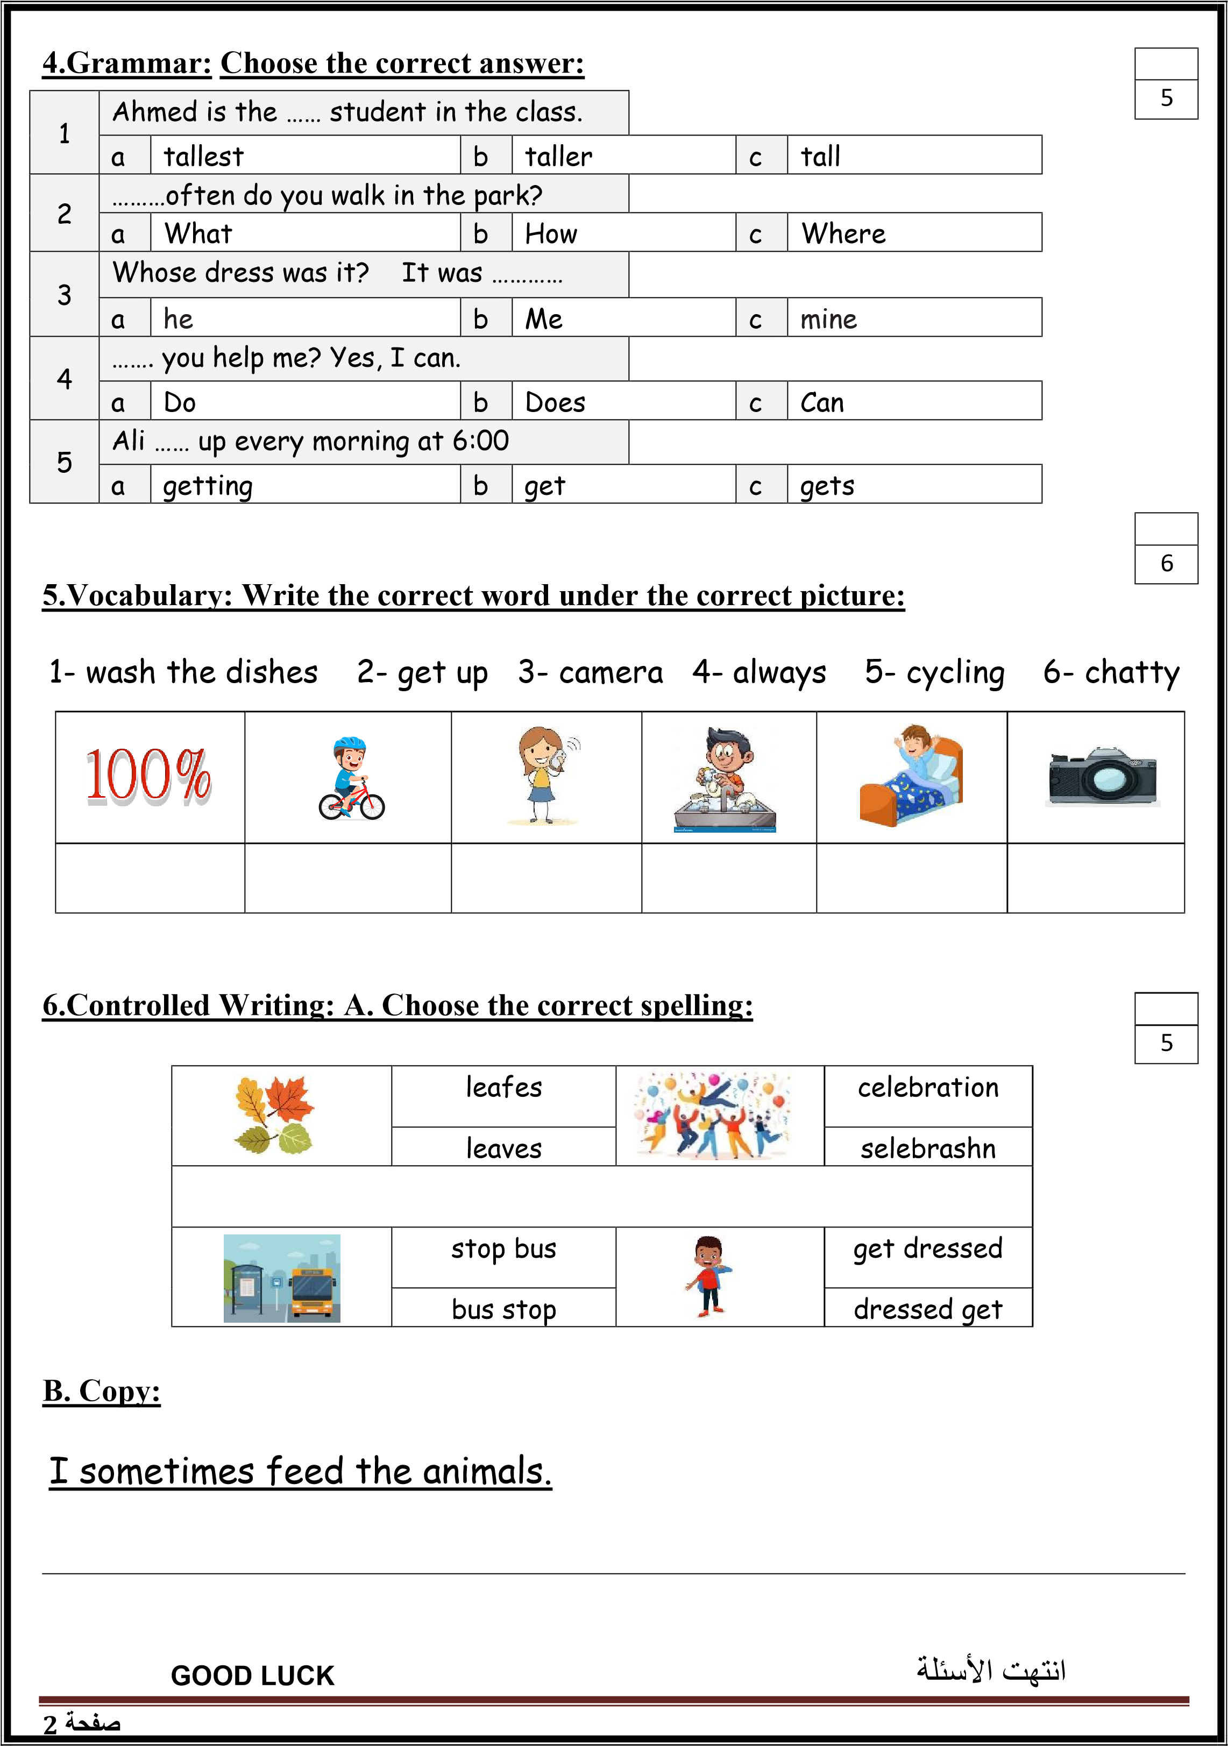

Kingdom of Saudi Arabia 5th & 6th Elementary Grade

Ministry of Education Time: An hour and a half

3rd Elementary School Number of papers: 3 . Final Exam – First Term – 1446 AH

|  |  |  |  |  |  |  |  |  |  |  |  |  |
| --- | --- | --- | --- | --- | --- | --- | --- | --- | --- | --- | --- | --- |
| 1. **General Questions:**   **/6** | | | | | | | | | | | | |
| 1. **Choose the correct answer:** | | | | | | | | | | | | |
| **1- What are you afraid of?**  a- my little brother b- spiders | | | | | | | | | | | | |
| **2- What school subject is more difficult?**  a- Math b- I go to school by bus | | | | | | | | | | | | |
| **3- Who is chatty in your family?**  a- My sister likes to talk a lot b- My brother doesn’t talk a lot | | | | | | | | | | | | |
| **4- How often do you see your cousins?**  a- It is mine b- I always see them | | | | | | | | | | | | |
| **5- Can I help you with your homework?**  a- Yes, please b- I think fish | | | | | | | | | | | | |
| **6- What are you doing now?**  a- I am watching TV b- I have 3 brothers | | | | | | | | | | | | |
| 1. **Controlled Writing:**   **/5** | | | | | | | | | | | | |
| 1. **Rearrange the words to form a sentence:** | | | | | | | | | | | | |
| photos – I – take – rarely | | | | | | | | | | | | |
|  | | | | | | | | | | | | |
| 1. **Fill in the missing words:** | | | | | | | | | | | | |
| **(takes out – feed – sweep – wash – make – clears)** | | | | | | | | | | | | |
| My brother and I help our grandparents on Saturdays. I usually **(1)……………... the floor** and **(2) ……………...** **the beds**. Then, I **(3)……………...** **the animals**. My brother **(4)……………...** **the trash**. My brother always **(5)……………... the table** after we eat and then I **(6)……………...** **the dishes** for my grandma. | | | | | | | | | | | | |
| 1. **Reading short sentence:**   **/4** | | | | | | | | | | | | |
| 1. **Read the sentences then match them with the correct pictures:** | | | | | | | | | | | | |
| |  |  |  |  | | --- | --- | --- | --- | | Download Transportation / Transportation Home Png Free - Get On The Bus ... | Shy clipart, Shy Transparent FREE for download on WebStockReview 2024 | thumbs up clipart transparent 10 free Cliparts | Download images on ... | Brecksville Kids Dentistry | Pediatric Dentist | Brecksville, OH | | a-_I get on the bus.  b-_I get off the bus. | a-_She is shy.  b-_She is lazy. | a-_It is good.  b-_It is terrible. | a-_I often go cycling  b-_I often go fishing | | | | | | | | | | | | | |
| 1. **Grammar:**   **/5** | | | | | | | | | | | | |
| 1. **Choose the correct answer:** | | | | | | | | | | | | |
| 1. **They** ……… swimming in the pool. 2. was b- were c- is | | | | | | | | | | | | |
| 1. It is **her dress**. It is ………… 2. yours b- mine c- hers | | | | | | | | | | | | |
| 1. Huda is ………… **than** Rana. 2. tall b- tall**er** c- tall**est** | | | | | | | | | | | | |
| 1. Hind ………… a story **now**. 2. read b- read**s** c- **is** read**ing** | | | | | | | | | | | | |
| 1. ………… Ali **catch** the bus? 2. Does b- Is c- Are | | | | | | | | | | | | |
| 1. **Vocabulary:**   **/6** | | | | | | | | | | | | |
| 1. **Choose the correct answer:** | | | | | | | | | | | | |
| Free Danger Sign, Download Free Danger Sign png images, Free ClipArts ... | | Pizza Clipart Graphic by Illustrately · Creative Fabrica | | Spatula - Openclipart | | | Contest - Picture This Clothing | | Bucket | Illustrations, Art, Spring | | 77,359 Friends Clipart Images, Stock Photos & Vectors | Shutterstock ... | |
| different  dangerous | | pizza  fish | | brilliant  surprised | | | car  comic book | | broom  bucket | | Exciting  Helpful | |
|  | | | | | | | | | | | | |
| 1. **Orthography:**   **/4** | | | | | | | | | | | | |
| 1. **Choose the correct missing letters:** | | | | | | | | | | | | |
| Strong man on fire screaming cartoon. Vector clip art illustration ...  **st__ong** | | | **Camera Illustration Images | Free Vectors, Stock Photos & PSD**  **ca__era** | | | Premium Vector | 15397  **parr__t** | | | | **g__itar** | | |
| **r** | **c** | | **m** | | **n** | **a** | | **o** | | **e** | | **U** |
| Dust clipart, Picture #193108 dust clipart  **d__st** | | | **chicke__** | | | Chatty Girl Stock Illustrations – 28 Chatty Girl Stock Illustrations ...  **chatt__** | | | | rabbit transparent background, AI Generative 31615881 PNG  **r__bbit** | | |
| **a** | **u** | | **u** | | **n** | **i** | | **y** | | **a** | | **B** |

**BEST OF LUCK ☺**

**Ms. Tahani Al-Ghamdi**