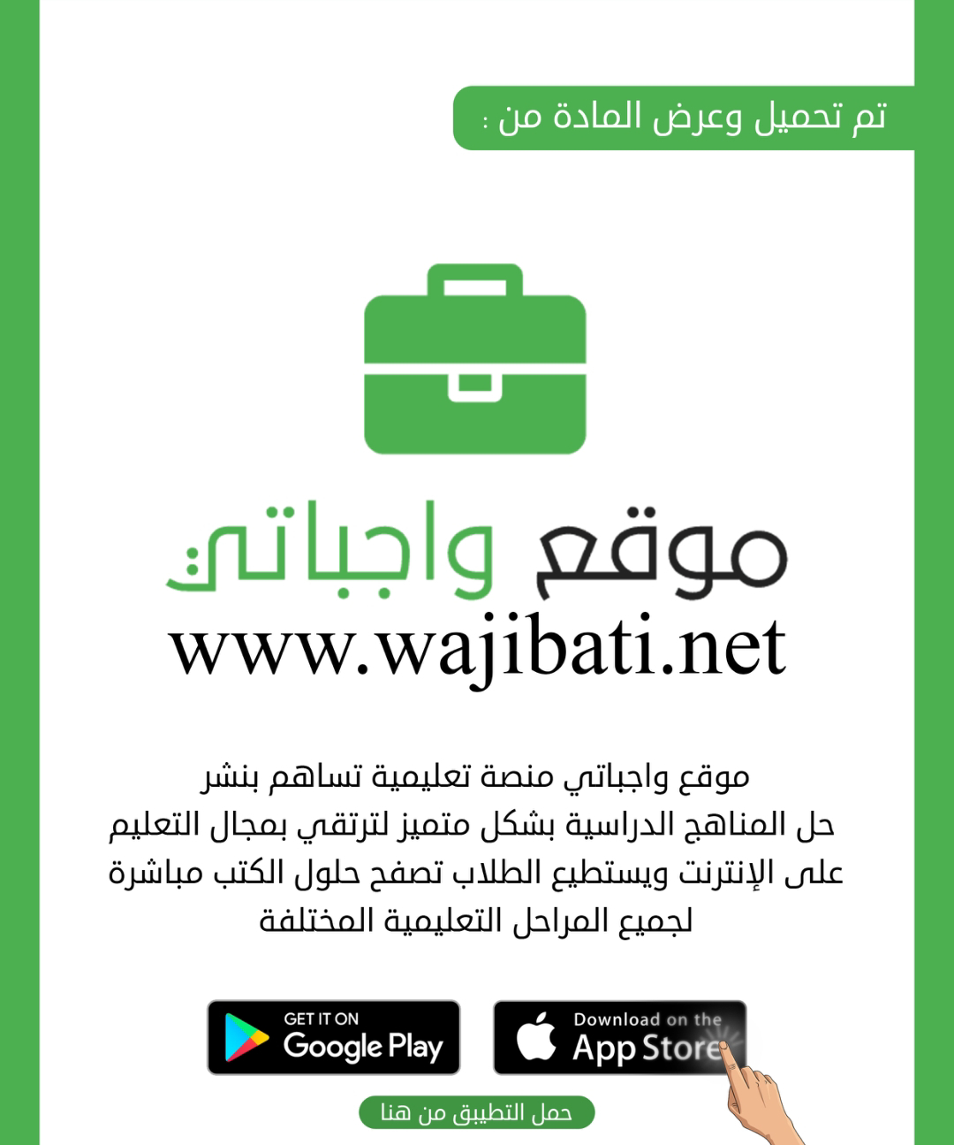



**التاريخ : / / 1445هـ**

**الصف: السادس الابتدائي**

**الزمن: ساعة ونصف**

**المادة : اللغة الإنجليزية**

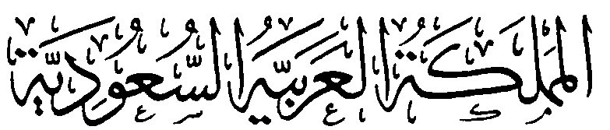

**وزارة التعليم**

**الإدارة العامة للتعليم بمنطقة .................**

**مدرسة ......................................**

**اختبار اللغة الإنجليزية نهائي – الدور الأول – للصف السادس – الفصل الدراسي الثالث 1445ه**

اسم الطالب: ..................................................... الفصل: .........

6

**I- General Questions:**

A- Match the questions in column (A) with the correct answers in column (B):

|  |  |
| --- | --- |
| B | A |
| ( ) I'm going to Jeddah.  ( ) Yes, I got up early this morning.  ( ) I'm going diving.  ( ) I should drink a lot of water.  ( ) I have a headache .  ( ) Go straight and you'll find it. | 1- Did you get up early this morning?  2- What's the matter?  3- Where are you going at weekend?  4- Where's the post office?  5- What are you going to do there?  6- What should you do to live in a healthy life? |

**II- Controlled Writing:**

5

A- Complete the sentences with the correct word:

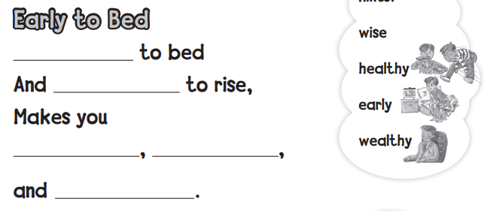

4

**III- Reading Short Sentence:**

A- Read the sentences and match them with the correct pictures:

**1-** I should brush my teeth. **2-** No parking **3-** I have an earache **4-** I shouldn't eat junk food.

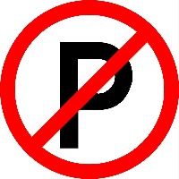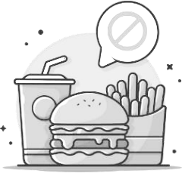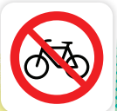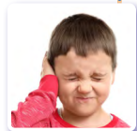

**IV- Grammar:**

5

A) Choose the correct word:

1- Yesterday, I ( play - played ) computer games.

2- He ( am - is ) going to the book store.

3- We are going to ( visit - visited ) Abha.

4- Last year, I [ went – go – going ] to Riyadh..

5- What are ( she - they ) doing?

6

**V- Vocabulary:**

A) Write the correct number under each picture:

**1**- butcher shop **2**- shower **3**- stomachache **4**- burger **5**- candy store **6**- flower store

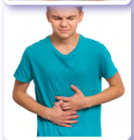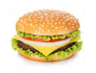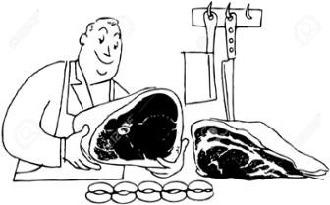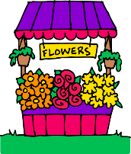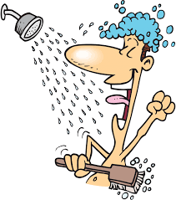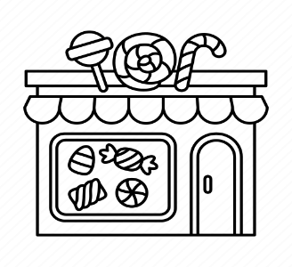

( ) ( ) ( ) ( ) ( ) ( )

**VI- Orthography:**

4

A) Choose the correct letter:

ir ue sc ur

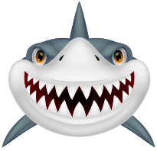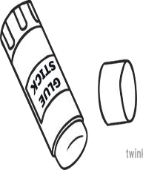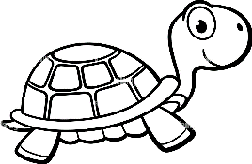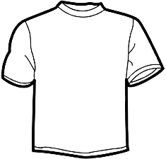

4- sh\_ \_ t 1- t \_ \_ tle 2- **\_ \_ ary** 3- gl \_ \_

**التاريخ : / / 1445هـ**

**الصف: السادس الابتدائي**

**المادة : اللغة الإنجليزية**



**وزارة التعليم**

**الإدارة العامة للتعليم بمنطقة ........**

**مكتب ............**

**مدرسة** .....................



**اختبار اللغة الإنجليزية نهائي – الدور الأول – للصف السادس – الفصل الدراسي الثالث 1445ه**

اسم الطالب: ..................................................... الفصل: .........

|  |
| --- |
|  |
| 6 |

**1.General Questions: A. Match "A" with "B":**

|  |  |
| --- | --- |
| B | A |
| ( ) I should drink a lot of water.  ( ) I'm going diving.  ( ) Go straight and you'll find it.  ( ) I'm going to Jeddah.  ( ) I have a headache .  ( ) Yes, I got up early this morning. | 1- Did you get up early this morning?  2- What's the matter?  3- Where are you going at the weekend?  4- Where's the post office?  5- What are you going to do there?  6- What should you do to live in a healthy life? |

|  |
| --- |
|  |
| 4 |

**2.Reading Short Sentence: Choose (** 🗸 **) or (** 🗴 **)**

|  |  |  |
| --- | --- | --- |
| ‪Cute Boy Brushing His Teeth Stock Illustration - Download Image Now -  Brushing Teeth, Child, Toothbrush‬‏ 1. I should brush my teeth. | 🗸 | 🗴 |
| No Parking Sign Stock Vector Illustration and Royalty Free No Parking Sign  Clipart 2. No parking. | 🗸 | 🗴 |
| Young Man Suffering From Headache Royalty Free SVG, Cliparts, Vectors, and  Stock Illustration. Image 134198976. 3. I have a stomachache. | 🗸 | 🗴 |
| Fast Food Clipart Images - Free Download on Freepik 4. I shouldn't eat junk food. | 🗸 | 🗴 |

|  |
| --- |
|  |
| 4 |

**3.Orthography: Choose the missing letters:**

|  |  |  |  |
| --- | --- | --- | --- |
| ur - ir | sk - ck | qu - ue | ie - ir |
| t\_\_ \_\_tle | Hand Drawn Women Skirt Doodle Isolated On White Background Stock  Illustration - Download Image Now - iStock  \_\_ \_\_ irt | Glue Sticks Clipart Free Images At Vector Clip Art Online, , 58% OFF  gl \_\_ \_\_ | Long Sleeve T Shirt Clipart | Free Images at Clker.com - vector clip art  online, royalty free & public domain  sh\_\_ \_\_t |

**4.Grammar: Choose the correct answer:**

|  |  |  |  |  |
| --- | --- | --- | --- | --- |
| 1 | Yesterday, I …… computer games. | | | |
| a | played | b | play | | c | playing |
| 2 | He …… going to the book store. | | | |
| a | is | b | am | | c | are |
| 3 | We are going to …… Abha. | | | |
| a | visit | b | visited | | c | visiting |
| 4 | Last year, I …… to Riyadh. | | | |
| a | go | b | went | | c | goes |
| 5 | What are …… doing? | | | |
| a | he | b | she | | c | they |

|  |
| --- |
|  |
| 5 |

|  |
| --- |
|  |
| 6 |

**5.Vocabulary: Write the correct word under the correct picture:**

1- flower store 2- no balls 3- globe 4- leader 5- burger 6- shower

|  |  |  |  |  |  |
| --- | --- | --- | --- | --- | --- |
|  | No Ball Games Stock Illustrations – 220 No Ball Games Stock Illustrations,  Vectors & Clipart - Dreamstime | Premium Vector | Cartoon flower shop flower shop vector | Shower Clip Art at Clker.com - vector clip art online, royalty free &  public domain | Hamburger Clipart | Free Download Clip Art | Free Clip Art | on Clipart  Library | Flock Birds Leadership Vector Concept Stock Vector (Royalty Free) 735217288  | Shutterstock |
|  |  |  |  |  |  |

|  |
| --- |
|  |
| 5 |

**6.Controlled Writing: A. Choose the correct spelling:**

|  |  |  |  |
| --- | --- | --- | --- |
|  | math |  | ltbe |
| atmh | belt |
|  | | | |
| 2,600+ Bus Stop Stock Illustrations, Royalty-Free Vector Graphics & Clip Art  - iStock | Bus stop sign, Bus, Bus stop icon | bus stop |  | ertaw |
| stop bus | water |

**B. Copy:**

What would you like to eat?

\_\_\_\_\_\_\_\_\_\_\_\_\_\_\_\_\_\_\_\_\_\_\_\_\_\_\_\_\_\_\_\_\_\_\_\_\_\_\_\_\_\_\_\_\_\_\_\_\_\_\_\_\_\_\_\_\_\_\_\_\_\_\_\_\_\_\_\_\_\_\_\_\_\_\_\_\_\_\_\_\_\_\_\_\_

انتهت الأسئلة  **GOOD LUCK**

|  |  |  |
| --- | --- | --- |
| المملكة العربية السعودية  وزارة التعليم  إدارة التعليم ب  مكتب تعليم  الابتدائية |  | **المادة: اللغة الإنجليزية**  **الصف: السادس ابتدائي**  **الزمن: ساعة و نصف**  **عدد الأوراق : ٣ أوراق**  **عدد الأسئلة : ٦ أسئلة** |
| اختبار نهاية الفصل الدراسي الثالث للعام الدراسي ١٤٤٥هـ | | |

6

**Q1 : General Questions**

|  |
| --- |
| C:\Users\user\Desktop\exams\clipart\images (30).jfif 1– Do you have school lunch at your school ?  A. It has a big yellow bus B. No, we don't |
| C:\Users\user\Desktop\exams\clipart\images (31).jfif 2– Which grade are you in this year ?  A. 5th grade . B. 6th grade . |
| 3- Where is the supermarket ?  A. No, we don’t. B. It’s near here. |
| 4– What should you do to live a healthy life ?  A. I should get up early . B . I should eat too much . |
| C:\Users\user\Desktop\exams\clipart\download (6).jfif5- Which subject do you like ?  A. I like English B . I live in Taif . |
| C:\Users\user\Desktop\exams\clipart\images (33).jfif6- How much is the jacket ?  A. It's 100 SR.. B. Yes, thanks. |

**- Choose the correct answer**

4

**Q2 : Reading Short Sentences**

- Match the picture with the correct sentence :

|  |  |  |  |
| --- | --- | --- | --- |
| **1-**  **I have a toothache. 2-**  **I do some exercises.**  **3-**  **Don't shout speak clearly. 4-**  **I shouldn't drink too much soda.** | | | |
| C:\Users\user\Desktop\exams\clipart\download (9).jfif | C:\Users\user\Desktop\exams\clipart\images (34).jfif | No Shouting Sign Vector Images (over 210) | C:\Users\user\Desktop\exams\clipart\images (35).jfif |

**1**

5

**Q3 : Controlled Writing**

**- Do as shown between brackets :**

|  |
| --- |
| 1- you? - I – Can – help ( Rearrange )  …………………………………………………………………………………………………. |
| 2- had - Rana -lamb. - a little ( Rearrange )  …………………………………………………………………………………………………. |
| 3- bakery. \_ to \_ the \_ going \_ She's ( Rearrange )  ………………………………………………………………………………………………….. |
| 4- I \_\_\_\_\_\_\_\_\_\_\_\_\_\_\_ a lot of water . ( choose )  ( do - drink - eat ) |
| 5- I \_\_\_\_\_\_\_\_\_\_\_\_\_\_\_ to bed early. ( choose )  ( take - go - eat ) |

6

**Q4 : Vocabulary**

**- Write the correct words under each picture:**

**tissue \_ school bus \_ school uniform**

**flower store \_ No Parking \_ headache**

**2**

|  |  |  |
| --- | --- | --- |
|  |  | Flower Shop Clipart Flower Stand Florist Girl Selling - Etsy Israel |
|  |  |  |
|  | School Bus Vector Isolated Stock Illustration - Download Image Now - School  Bus, Bus, Vector - iStock | Free Tissues Cliparts, Download Free Tissues Cliparts png images, Free  ClipArts on Clipart Library |
|  |  |  |

5

**Q5 : Grammar**

**- Choose the correct answer**

|  |  |  |  |
| --- | --- | --- | --- |
| watch | eat | play | **1–**  **I should \_\_\_\_\_\_three meals a day.** |
| is | are | am | **2-**  **We \_\_\_\_\_\_ going to the bookstore.** |
| shopping | shop | shopped | **3– She is going to \_\_\_\_\_\_\_\_ in Dubai.** |
| brushed | brush | brushes | **4- Did you \_\_\_\_\_\_\_ your teeth ?** |
| is | were | was | **5- There \_\_\_\_\_\_\_\_ two floors.** |

**Q6 : Orthography**

4

**- Choose the correct answer**

|  |  |  |  |  |  |  |  |  |
| --- | --- | --- | --- | --- | --- | --- | --- | --- |
| C:\Users\user\Desktop\exams\clipart\download (9).png | | C:\Users\user\Desktop\exams\clipart\download (8).png | | | IMG_256 | |  | |
| c \_ be | | \_ \_arf | | | gl\_ \_ | | g\_ \_l | |
| u | y | | sc | sk | ue | oo | ir | ar |

|  |  |  |  |  |  |  |  |  |
| --- | --- | --- | --- | --- | --- | --- | --- | --- |
|  | | صورة تحتوي على تلبيس, تنورة, أسود وأبيض  تم إنشاء الوصف تلقائياً | | | C:\Users\user\Desktop\exams\clipart\download (10).png | | صورة تحتوي على مستطيل, إطار الصورة, الإطار, التصميم  تم إنشاء الوصف تلقائياً | |
| sh\_ \_t | | \_ \_irt | | | b\_ \_ger | | \_ \_uare | |
| or | ir | | sq | sk | or | ur | sk | sq |

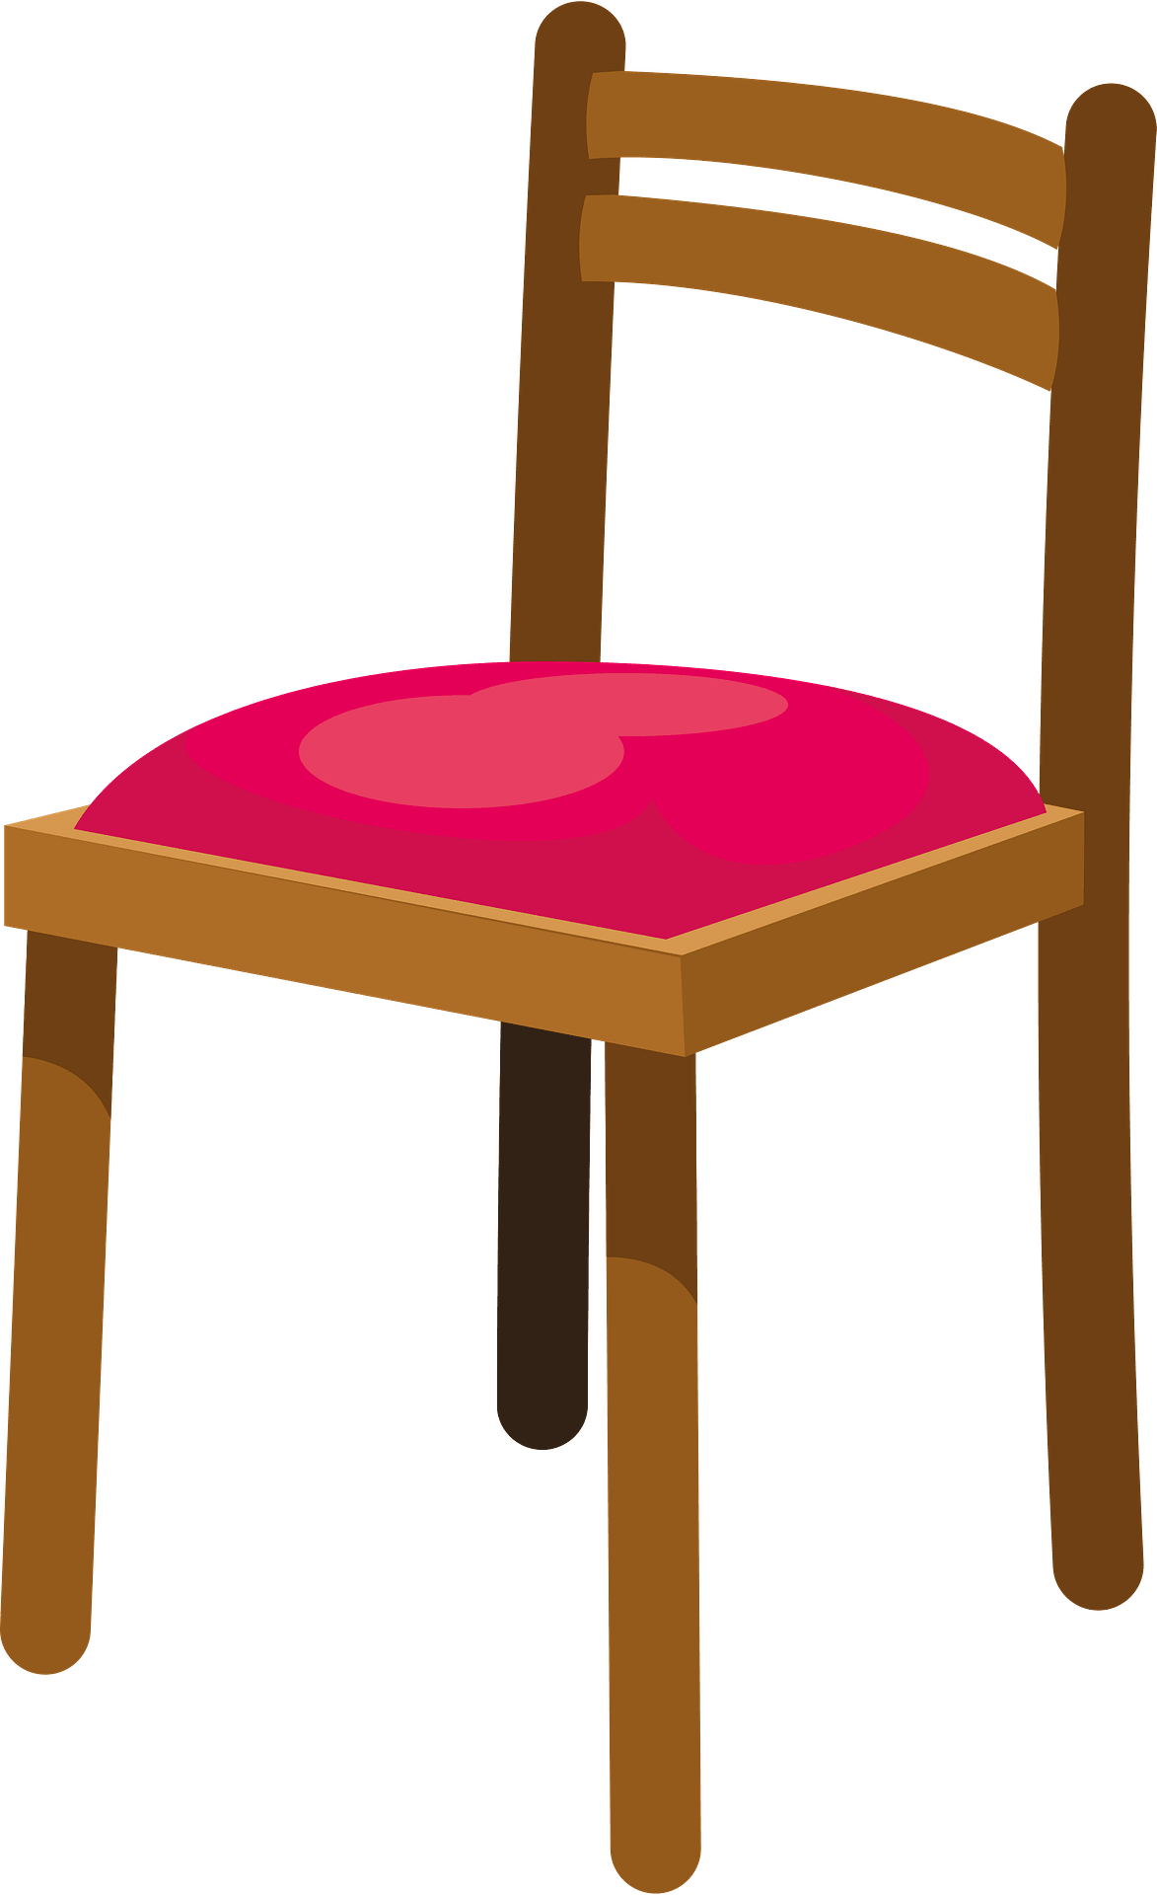Best wishes ♥ ♥

Najla 😊

**3**



المادة: اللغة الإنجليزية

الزمن: ساعة و نصف

عدد الأوراق: ٣

عدد الأسئلة: ٦

المملكة العربية السعودية

وزارة التعليم

الإدارة العامة للتعليم ب

مكتب التعليم ب

المدرسة

|  |  |  |  |  |  |
| --- | --- | --- | --- | --- | --- |
| السؤال | الدرجة رقماً | الدرجة كتابةً | المصححة | المراجعة | المدققة |
| **الأول**  **General Questions**  **( 6 marks )** |  | فقط |  |  |  |
| **الثاني**  **Reading short sentence**  **(4 marks )** |  |  |  |  |
| **الثالث**  **Controlled Writing**  **(5 marks)** |  | فقط |  |  |
| **الرابع**  **Vocabulary**  **( 6 marks )** |  | فقط |  |  |
| **الخامس**  **Grammar**  **( 5 marks )** |  | فقط |  |  |
| **السادس**  **Orthography**  **( 4 marks )** |  | فقط |  |  |
| **مجموع الاختبار التحريري**  **30 درجات** |  | فقط | فقط |  |

**اسم الطالبة**: ................................................................................................................................................................

**الصف**: سادس / ..............................................................................................................................................

**رقم الجلوس**: .............................................................................................................................................................

## الاختبار النهائي لمادة اللغة الانجليزية للمرحلة الابتدائية للصف السادس الابتدائي

## الفصل الدراسي الثالث للعام الدراسي ١٤٤٥هـ

|  |  |  |
| --- | --- | --- |
| المملكة العربية السعودية  وزارة التعليم  الإدارة العامة للتعليم بمنطقة\_\_\_\_\_\_  مكتب التعليم\_\_\_\_\_\_\_\_\_\_\_\_\_\_\_  المدرسة \_\_\_\_\_\_\_\_\_\_\_\_\_\_\_\_\_  الرقم الوزاري : \_\_\_\_\_\_\_\_\_\_ | **شعار** | اسم المادة : اللغة الإنجليزية               الصف:  السادس ابتدائي               القسم: اللغة الإنجليزية               اليوم :  \_\_\_\_\_\_\_\_\_\_               التاريخ:    /     / 1445هـ               الزمن: |

أسئلة اختبار مادة اللغة الإنجليزية للصف السادس ابتدائي الفصل الدراسي (الثالث)/الدور الأول للعام الدراسي 1445هـ

**أولاً: بيانات الطالب /ة:**

|  |  |  |  |
| --- | --- | --- | --- |
| **اسم الطالب/ة** |  | | |
| **الشعبة** |  | **رقم الجلوس** |  |

**ثانياً: درجات الاختبار:**

|  |  |  |  |  |  |  |  |
| --- | --- | --- | --- | --- | --- | --- | --- |
| **Total** | **6** | 5 | 4 | 3 | 2 | 1 | **Question** |
| 30 | **ـــــــــــــ**  **4** | **ـــــــــــــ**  **6** | **ـــــــــــــ**  **5** | **ـــــــــــــ**  **4** | **ـــــــــــــ**  **5** | **ـــــــــــــ**  **6** |  |
| **Mark** |  |  |  |  |  |  |  |

|  |  |  |  |  |  |
| --- | --- | --- | --- | --- | --- |
|  | Checked by: |  | Revised by: |  | Corrected by: |
|  | Signature |  | Signature |  | Signature |

**I-General Questions**

1. **Answer the following questions:**

6

1) What is your favorite subject?

……………………………………………

2) What time does your school start?

……………………………………………

3) What should you do to live a healthy life?

………………………………………………….

**"B) Match  "A"  with the suitable parts in   "B":**

Turn to next page

|  |  |  |  |  |
| --- | --- | --- | --- | --- |
| "B" | | "A" | | |
| the art workshop. |  | We are going to the bookstore | 1 | |
| because we want some books. |  | The Kingdom of Saudi Arabia is blessed | **2** | |
| because of the two Holy Mosques. |  | How long does it take to get to Tokyo? It takes | **3** | |
| makes you tired. |  | The weather is cold. | | **4** |
| about eight hours. |  | The best place in the school is | | **5** |
| because she never goes to the dentist. |  | She has a toothache | | **6** |
| I must buy a jacket. |  |  | |  |

**II-Controlled Writing**

5

1. **Fill in the blank to complete the dialogue** 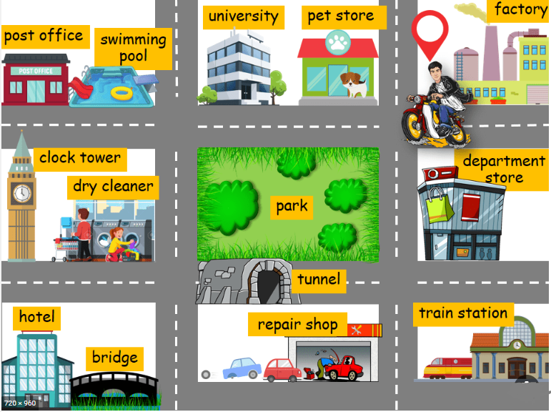

A: Excuse me. Where is the university?

B: ………………………………………….…………….. .

1. **Use the table to write one place you want to go to on your trip and what you want to do there.**

|  |  |  |
| --- | --- | --- |
| Najran | walk | traditional dishes |
| Jeddah | eat | along the sea |

………………………………………………………………………………………………………………….

1. **Use the table below to choose the sentence which is belong to :**

English class rule: ……………………………………….…

Home rule: ……………………………………………………..

|  |  |  |  |
| --- | --- | --- | --- |
| Sleep early | Don't shout; speak clearly | Wash your hands before eating. | Keep of grass in the park |

1. **Complete with the right word:**
2. I like to drink milk ……..… orange juice ………….. I don't like hot chocolate.  **( and, or , but , because )**

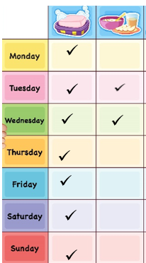

1. **Read Ahmad`s daily routine table, then answer the following question.**
2. Ahmad…………………………… takes shower. He……………………………….. has his breakfast.

**( usually-sometimes- never- always)**

Turn to next page

**III-Reading Short Sentences**

4

1. **Read the flowing text then answer the question?**

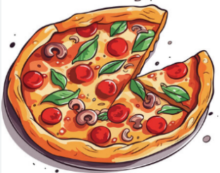**The Food Court**

After wandering a lot in the park, we went to the food court.

My dad brought our drinks first. Then he brought our pizzas.

1. **Where did we go after wandering in the park?**

………………………………………………………………………….

1. **What did we eat?**

………………………………………………………………………

1. **Choose the correct response:**
2. The people will come from all over the ……………………………
3. business b. globe c. leader d. medicine
4. Amal: I have a stomachache.

Sara: Did you……..

1. have breakfast? b. read a lot ? c. brush your teeth d. clean your ear?
2. My sister is in the fourth grade this year. Last year……….…. was in the……………. grade.
3. We want to buy …………… and ………… from bakery.

**IV-Grammar**

5

**A: Do as shown between brackets:**

1. I drink milk today.

……………………………………………………. (Change into the past)

1. She is going …….………………..……. Ice cream. ( Use to + verb)

**B: Choose the right answer:**

1. Sara (get up – got up– getting up – gets up) early this morning.
2. A: How (much - many - long – big) is this sweater?

B: It is 150 SAR.

1. It is (a – an – the – and) small black bag. The small black bag is mine.
2. There was (one – tow – three – four) bed in the room.
3. I shouldn't (skipped – skips – skipping – skip) breakfast.
4. My sister and I met some friends and played with (our – us – we – they).

Turn to next page

**V-Vocabulary**

6

**A:Answer the following questions:**

1. Write the name of the sign?

……………………………………………………………………………………….

1. Give the opposite word:

Weak X ……………

1. I eat all the soup because I was………………….. . ( Complete )
2. She is wearing …………………… ( Complete )

**B: Choose the correct answer:**

|  |  |  |  |
| --- | --- | --- | --- |
| 1- I want some (……………………………….). I am going to the flower store. | | | |
| plants | chocolate | pens | orange |
| 2- He is ……………………. He works a lot. | | | |
| Expensive | wealthy | salty | new |
| 3- You are going to watch………………………. in Riyadh | | | |
| surfing | snow | camel racing | waterfall |
| 4- The new shirt was too big. I took it back and got a ……………………..one | | | |
| small | smaller | big | bigger |
| 5- The ……………………..flew away | | | |
| lamb | whale | horse | Bird |
| 6- The car is ………………… as sky. | | | |
| blue | yellow | purple | White |
| 7- My favourite room is …………………………..There is a big library | | | |
| Living room | kitchen | bathroom | yard |
| 8-You use it to fix or stick things. | | | |
| Glass | Tissue | Glue | box |

Turn to next page

**VI-Orthography**

4

**A: Fill in the missing letters to complete the sentence:**

In J\_\_n\_\_ we like to have barbec\_\_ \_\_ in our garden.

**B: Write the missing letters:**

|  |  |  |
| --- | --- | --- |
|  |  |  |
| 1. \_\_ \_\_ irt | 1. T \_\_ \_\_ tle | 1. C \_\_b\_\_ |

**C: Choose the right letters:**

|  |  |
| --- | --- |
|  | **( sq \ sk \ sc )**  \_\_ \_\_ uare |
|  | **( ph \ pr \ br )**  \_\_ \_\_ice |
|  | **( Sl \ fl \ bl )**  \_\_ \_\_ag |

*End of the questions*